HOW TO TROUBLESHOOT PG WALL MISS WALL/ CATCHING UP (Example = Cluster oss2)

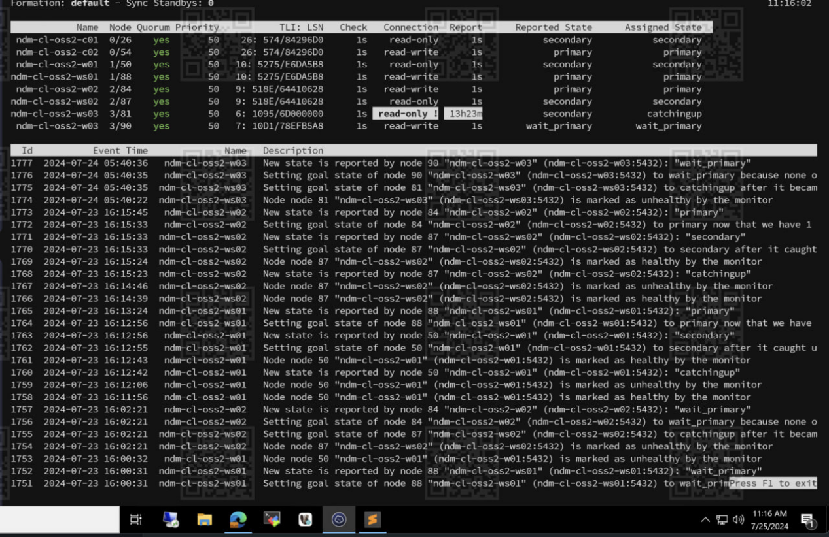
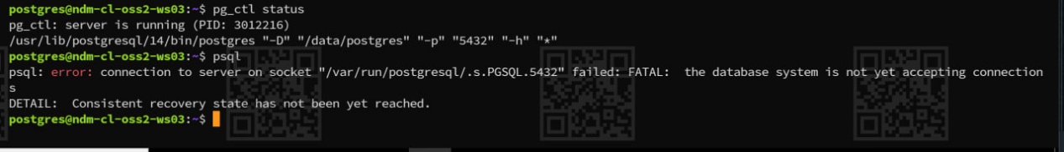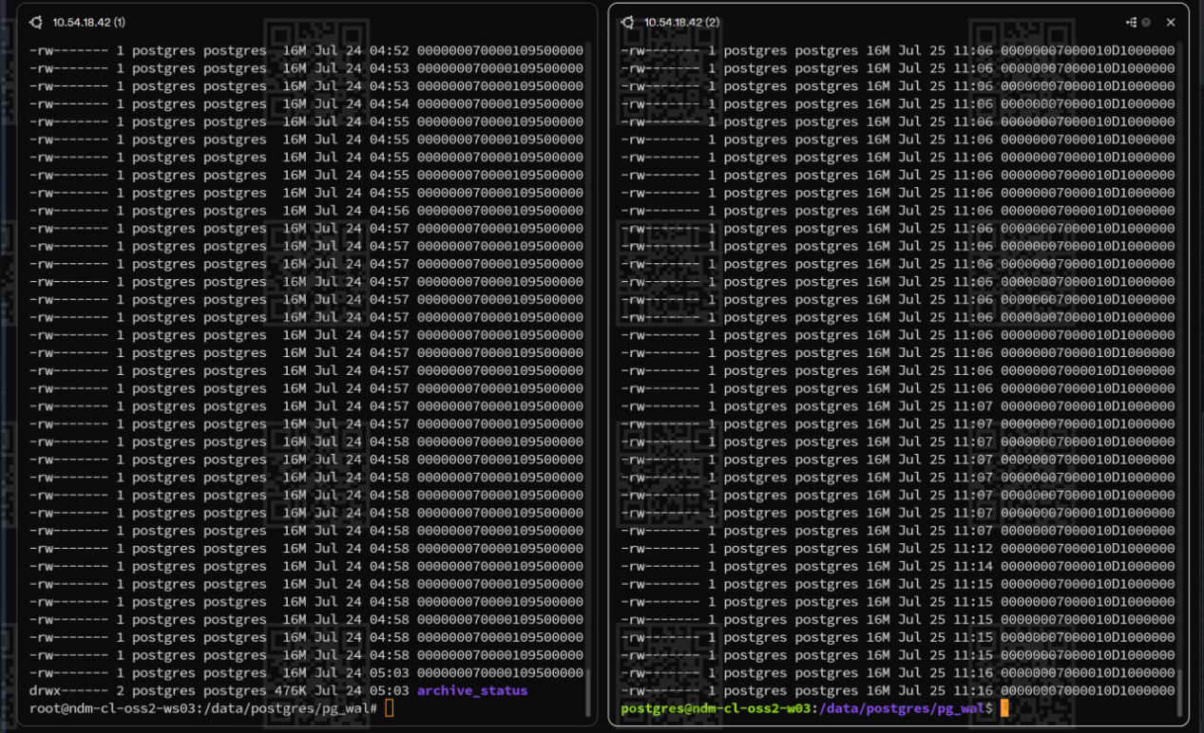

- Stop service pgfailover di yg error (ndm-cl-oss2-ws03)
- service pgautofailover stop

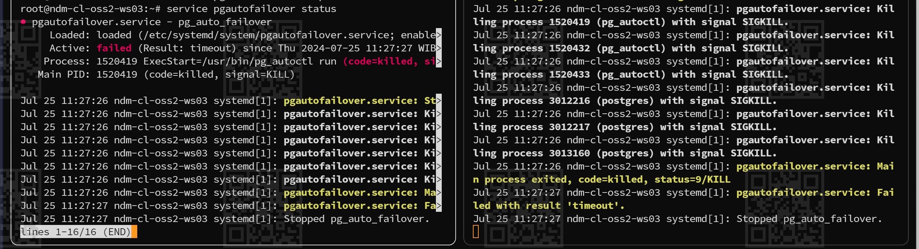

Stop pg_ctl

- Drop node di monitor (ndm-cl-oss2-m01)

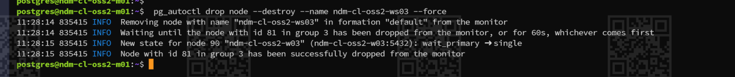

- Create node di vm yg problem (ndm-cl-oss2-ws03)

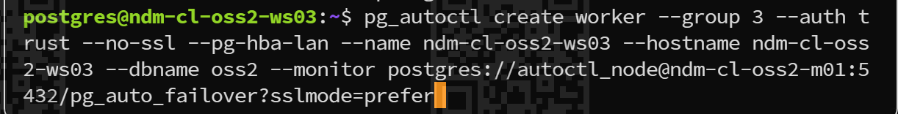

- Back up postgres di vm yg problem (ndm-cl-oss2-ws03)

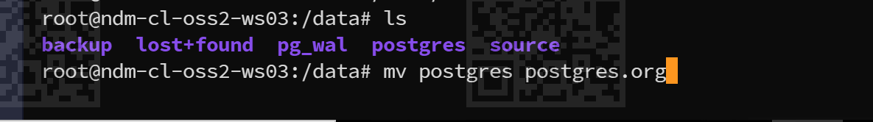

- Create new dir for postgres
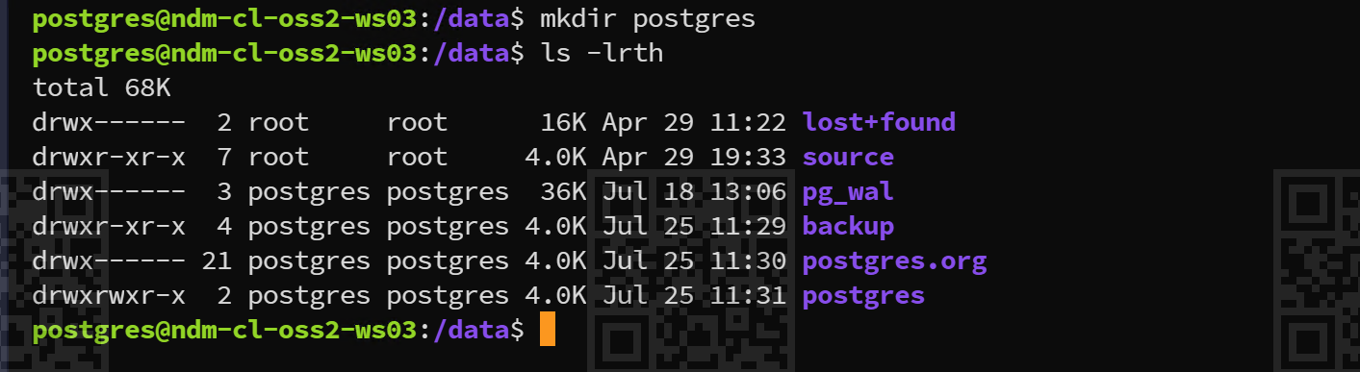

- Start service pg auto failovernya
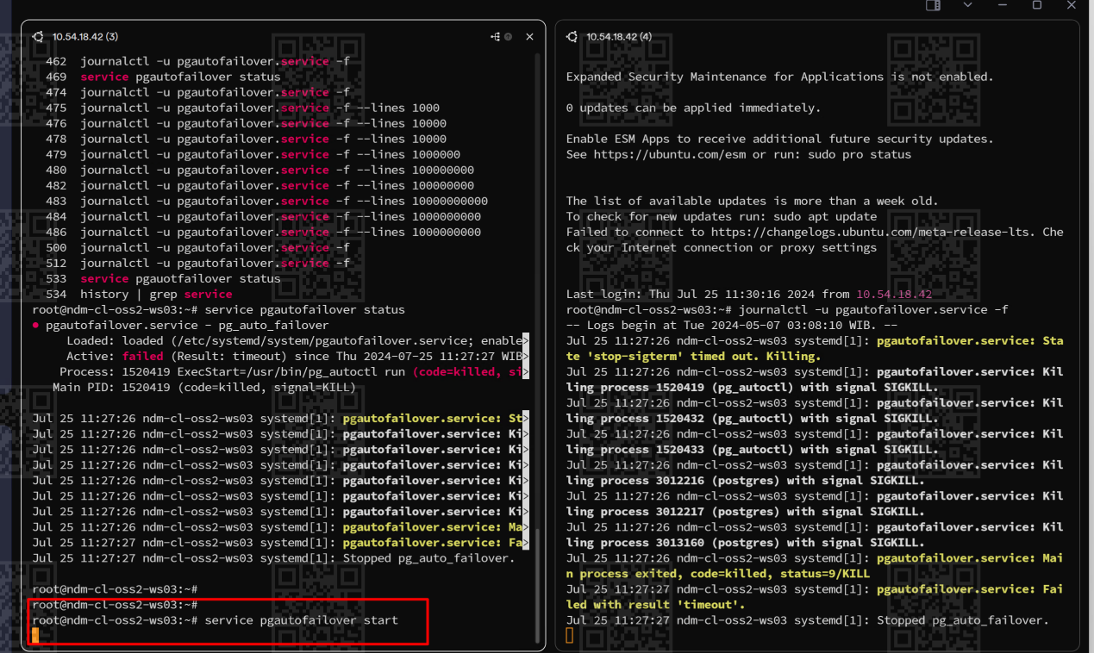

- Klo udah berjalan basebackup nya sekitar 20% hapus postgres.org
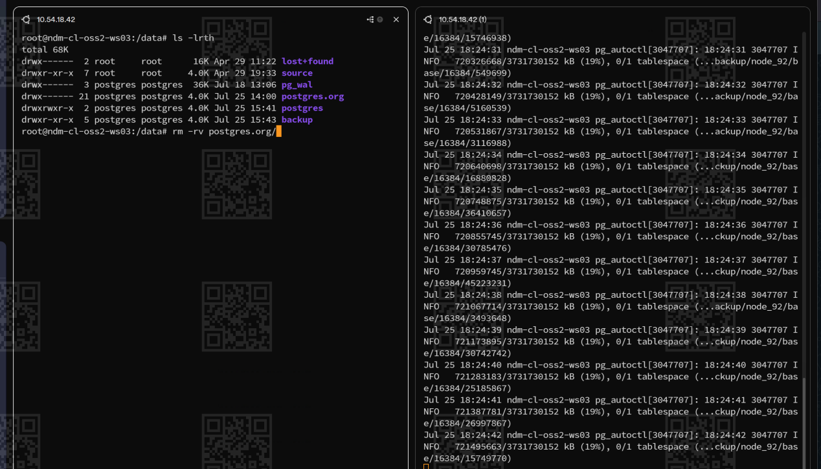

Data masuk > coor > 3 worker (w01,w02,w03) > 3 worker stand by (ws01,ws02,ws03)Pg wall > base

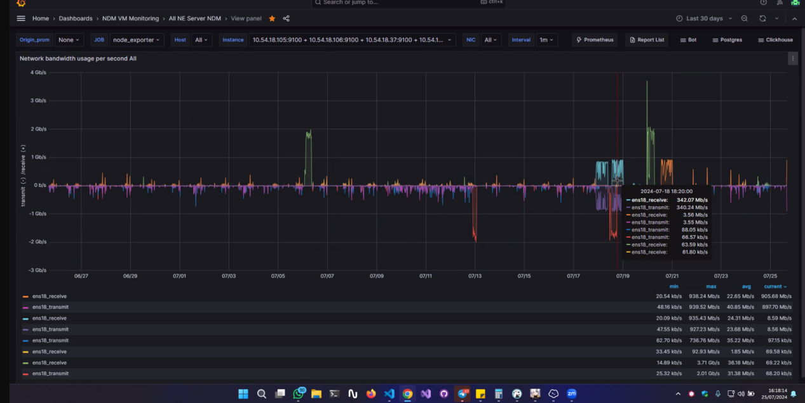

- Output sukses
